EXP 1 : Write a python program to implement Simple Calculator program?
Aim:
To write and execute a Python program to implement a simple calculator using the match-case statement for arithmetic operations.
Algorithm:
- Start the program.
- Get two numbers as input from the user.
- Display the menu of arithmetic operations: addition, subtraction, multiplication, and division.
- Get the user's choice of operation.
- Use the match-case statement to perform the selected operation.
- If division is selected, check whether the second number is zero.
- Display the result or an appropriate error message.
- Stop the program.
Program:
num1 = float(input("Enter first number: "))
num2 = float(input("Enter second number: "))
print("1. Addition (+)")
print("2. Subtraction (-)")
print("3. Multiplication (*)")
print("4. Division (/)")
choice = int(input("Enter your choice (1-4): "))
if choice == 1:
print("Result:", num1 + num2)
elif choice == 2:
print("Result:", num1 - num2)
elif choice == 3:
print("Result:", num1 * num2)
elif choice == 4:
if num2 != 0:
print("Result:", num1 / num2)
else:
print("Cannot divide by zero")
else:
print("Invalid choice")
Output:
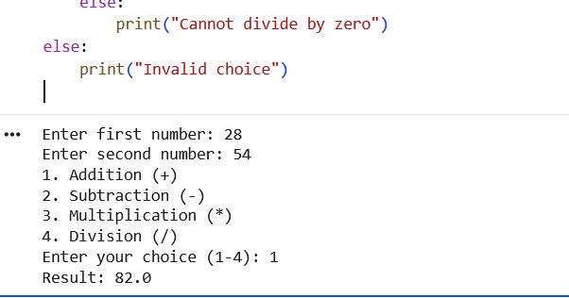

Exp 2 : ADDITION OF TWO MATRICES USING PYTHON
Aim:
To write and execute a Python program to add two matrices.
Algorithm:
- Start the program.
- Get the number of rows and columns from the user.
- Read the elements of the first matrix.
- Read the elements of the second matrix.
- Create an empty matrix to store the sum.
- Add the corresponding elements of both matrices using nested loops.
- Display the resultant matrix.
- Stop the program.
Program:
rows = int(input("Enter number of rows: "))
cols = int(input("Enter number of columns: "))
print("Enter elements of first matrix:")
A = []
for i in range(rows):
row = list(map(int, input().split()))
A.append(row)

print("Enter elements of second matrix:")
B = []
for i in range(rows):
row = list(map(int, input().split()))
B.append(row)
C = []
for i in range(rows):
row = []
for j in range(cols):
row.append(A[i][j] + B[i][j])
C.append(row)
print("Sum of two matrices:")
for row in C:
print(*row)
Output:
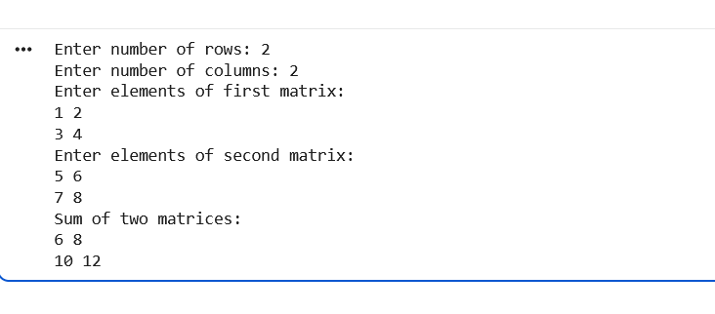
Exp 3 : Write a python program to Transpose a Matrix.
Aim:
To write and execute a Python program to find the transpose of a matrix.
Algorithm:
- Start the program.
- Get the number of rows and columns from the user.
- Read the elements of the matrix.
- Create a new matrix by interchanging the rows and columns of the original matrix.
- Display the transposed matrix.
- Stop the program.
Program:
4 rows = int(input("Enter number of rows: "))
cols = int(input("Enter number of columns: "))
print("Enter matrix elements:")
A = []
for i in range(rows):
row = list(map(int, input().split()))
A.append(row)
T = []
for j in range(cols):
row = []
for i in range(rows):
row.append(A[i][j])
T.append(row)
print("Transpose of the matrix:")
for row in T:
print(*row)
Output :
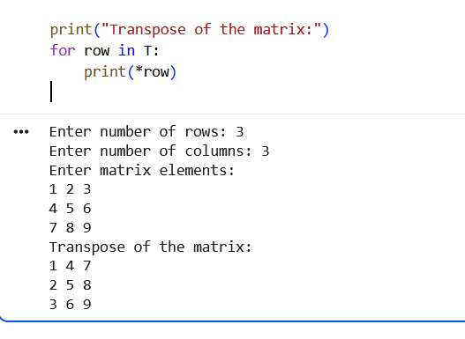
Exp 4 : Write a python program to sort the sentence in alphabetical order?
Aim:
To write and execute a Python program to sort the words in a sentence in alphabetical order.
Algorithm:
- Start the program.
- Get a sentence as input from the user.
- Split the sentence into individual words.
- Sort the words in alphabetical order using the sort() method.
- Display the sorted sentence.
- Stop the program.
Program:
sentence = input("Enter a sentence: ")
words = sentence.split()
words.sort(key=str.lower)
print("Sentence in alphabetical order:")
print(" ".join(words))
Output:
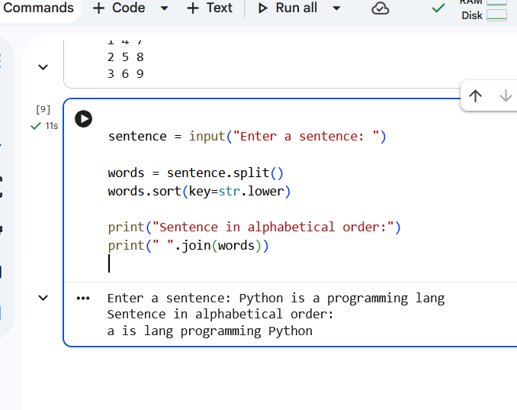

Exp 5 : Write a python program to implement List operations (Nested List, Length,
Concatenation, Membership, Iteration, Indexing and Slicing)?
Aim:
:To write and execute a Python program to implement list operations such as nested list, length, concatenation, membership, iteration, indexing, and slicing.
Algorithm:
- Start the program.
- Create two lists and a nested list.
- Find the length of a list using len().
- Concatenate two lists using the + operator.
- Check membership using the in operator.
- Iterate through the list using a for loop.
- Access elements using indexing.
- Extract elements using slicing.
- Display the results of all list operations.
- Stop the program.
Program:
L1 = [10, 20, 30, 40, 50]
L2 = [60, 70, 80]
nested = [[1, 2], [3, 4]]
print("List 1:", L1)
print("Nested List:", nested)
print("Length of List 1:", len(L1))
print("Concatenation:", L1 + L2)
print("Membership (30 in L1):", 30 in L1)
print("Iteration:")
for i in L1:
print(i)
print("Indexing (element at index 2):", L1[2])
print("Slicing (index 1 to 3):", L1[1:4])

Output:
